**Smart Cane**

**James Huang**

***james.huang@student.isb.bj.edu.cn***

**Abstract**

**Introduction**

* Nowadays, many smart devices are designed to be capable of many advanced abilities, such as Google navigation, Bluetooth connection to cell phones, etc. But few of them have tried applying computer vision to create an object identification and warning effect for the needy blind people. In this project, I will focus on designing a smart cane prototype that can identify obstacles and provide audio and vibrating warnings

**Success Criteria:**

* The smart cane’s camera has to be able to sense at least 2~3 types of objects within a certain range (let’s say 1 meter) and shout out what the object is with a speaker.

**Related Work:**

* <https://www.youtube.com/watch?v=J-VVh5ezqGA> (smart cane)
* <https://www.youtube.com/watch?v=Vg9rrOFmwHo> (camera & object detection)
* <https://www.youtube.com/watch?v=htVdRZN5JjY> (speaker)

**Methodology:**

* A combination of course-provided hardware, open-source software, and self-written code will be employed.
* Opencv library and python will be used

**Possible Tech:**

* *Sensor*
  + Environment/3D
    - The environment sensor can sense the surrounding and draw out a 3-dimensional map (usually used in auto-driving). However, the smart cane only needs to look at one direction within a few meters range.
    - Way too advance and expensive in this case.
  + Ultrasonic
    - Its property is just enough for my project
    - The school provides it
  + Radar
    - Way too expensive
    - Too good for sensing a few meters distance
  + Lidar
    - Way too expensive
    - Too good for sensing a few meters distance
  + Raspberry Pi Camera
    - Camera is the most commonly used sensor for object identification and detection.
    - And this sensor goes with the controller.
  + Human Presence
    - It uses heat to detect the presence of human, which means it cannot detect normal objects.
    - The school doesn’t provide
* *Actuator*
  + Motor for oscillation
    - The type of actuator I am most familiar with.
    - School provides
  + Actuators designed for oscillation purpose
    - If I can use a normal motor the school provides, why would I choose to buy this kind of actuator.
  + Raspberry Pi Speaker
    - School provides
* *Controls*
  + Candidate A: Microbit
    - Sometimes the area for coding is too small, thus it has limited flexibility, -- that’s why I decided to not use it as my controller.
  + Candidate B: Arduino
    - I have not found much resource on this one
  + Candidate C: Raspberry Pi Zero
    - I have managed to find some good resource on this one, so decided to use it.
    - Cheap

**MVP:**

* **Able to sense + detect objects using a Raspberry Pi-controlled-camera.**
* **Able to sense an object from 1 meter (at least) using an ultrasonic sensor.**
* **Able to oscillate when instructed to.**

**Materials**

* **Raspberry Pi Control**
* **Raspberry Pi Camera**
  + 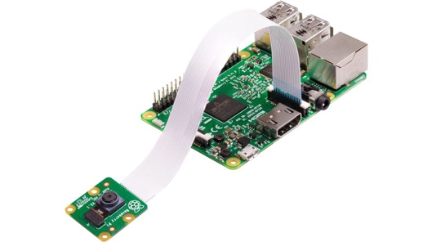
* **Raspberry Pi Speaker**
  + 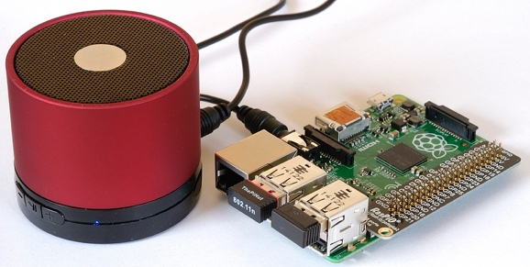
* **Computer**
* **Connecter to connect the computer and Raspberry Pi**
* **Ultrasonic Sensor**
* **Motor that can oscillate**
* **Tape (if needed)**
* **Stick (if needed)**

**Logic**

* The camera will always be on. When the system detects and recognizes an object, it will speak out the object name to warn the blind subject.
* Whenever the ultrasonic sensor senses something very close to the controller, it activates the motor which will create vibrations

**Product**

**Test**

